**RAJALAKSHMI ENGINEERING COLLEGE**

**RAJALAKSHMI NAGAR, THANDALAM – 602 105**



|  |
| --- |
| **CS23A34**  **USER INTERFACE AND DESIGN LAB** |
| **Laboratory Observation NoteBook** |

|  |
| --- |
| **Name :** SREE VARSSINI S  **Year/Branch/Section :** II/CSE/D  **Register No. :** 230701332  **Semester :** IV  **Academic Year:** 2024-25 |

**Ex. No. : 4b**

**Register No. : 230701332 Name : Sree Varssini K S**



**Conduct task analysis for an app (e.g., online shopping) and**

**document user flows. Create corresponding wireframes using**

**DIA.**

**Aim:**

The aim is to perform task analysis for an app, such as online shopping, document user flows, and create corresponding wireframes using Dia.

**Procedure:**

1. Install Dia:
   * Download Dia from the official website (<http://dia-installer.de/>)
   * Install Dia on your computer
   * Open Dia:
   * Launch the Dia application.
2. Create New Diagram:
   * Go to File -> New Diagram.
   * Select Flowchart as the diagram type.
3. Add Shapes:
   * Use the shape tools (rectangles, ellipses, etc.) to create wireframes for each screen.
     + For example:
       - Home Page: Rectangle
       - Product Categories: Rectangle
       - Product Listings: Rectangle
       - Product Details: Rectangle
       - Cart: Rectangle
       - Checkout: Rectangle
       - Order Confirmation: Rectangle
       - Order History: Rectangle
4. Connect Shapes:
   * Use the line tool to connect shapes, representing the user flows.
     + For example:
       - Home Page -> Product Categories
       - Product Categories -> Product Listings
       - Product Listings -> Product Details
       - Product Details -> Cart
       - Cart -> Checkout
       - Checkout -> Order Confirmation
       - Order Confirmation -> Order History
5. Label Shapes:
   * Double-click on each shape to add labels.
     + For example:
       - Label the rectangle as "Home Page", "Categories", "Product Listings", "Product Details", "Cart", "Checkout", "Order Confirmation", "Order History".
6. Save the Diagram:
   * Go to File -> Save As.
   * Save the diagram with a meaningful name, such as "Online Shopping App User Flows".

**Output:**

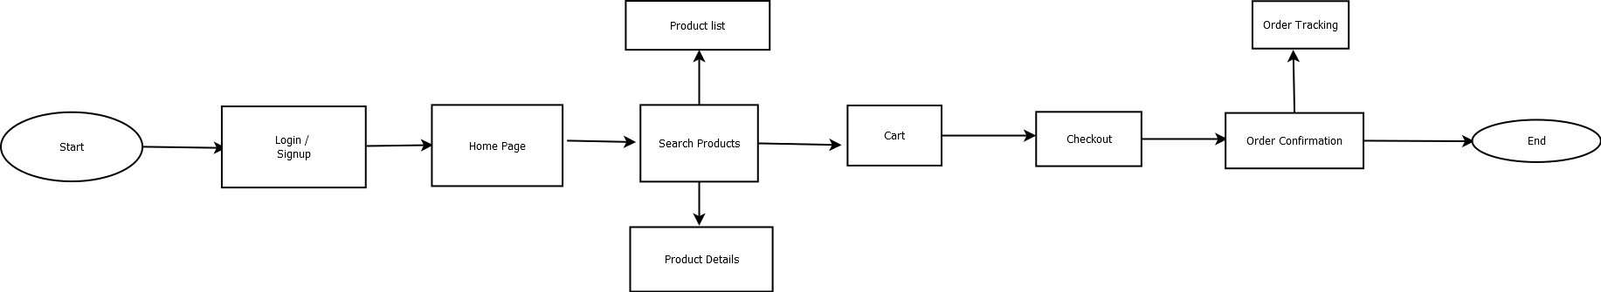

**Result:**

Hence the task analysis for an app, such as online shopping, document user flows, and create corresponding wireframes using Dia has been successfully studied and executed.